Introduction Lab – Food Truck

Class Diagram

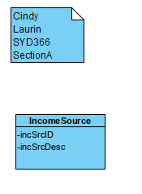

Systems Level Sequence Diagram

